JOINS

1. Write a query for the HR department to produce the addresses of all the departments. Use the LOCATIONS and COUNTRIES tables. Show the location ID, street address, city, state or province, and country in the output. Use a NATURAL JOIN to produce the results.
2. The HR department needs a report of all employees. Write a query to display the last name, department number, and department name for all the employees
3. The HR department needs a report of employees in Toronto. Display the last name, job,

department number, and the department name for all employees who work in Toronto.

1. Create a report to display employees’ last name and employee number along with their manager’s last name and manager number. Label the columns Employee, Emp#, Manager, and Mgr#, respectively
2. Repeat the last query to display all employees including King, who has no manager. Order the results by the employee number.

**---if you have time:**

1. Create a report for the HR department that displays employee last names, department numbers, and all the employees who work in the same department as a given employee. Give each column an appropriate label (it should produce a lot of rows…)

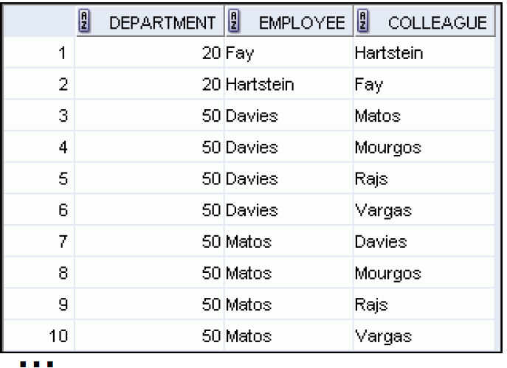

1. The HR department needs a report on sal grades and salaries. To familiarize yourself with the SAL_GRADES table, first look at the structure of the SAL_GRADES table. Then create a query that displays the name, job, department name, salary, and grade for all employees.

**--if you have even more time**

1. The HR department wants to determine the names of all the employees who were hired after Davies. Create a query to display the name and hire date of any employee hired after employee Davies.
2. The HR department needs to find the names and hire dates of all the employees who were hired before their managers, along with their managers’ names and hire dates